JK00 Kerry Un-numbered [Collotype] Series [1903]

Ph Charles Kerry
Pu Kerry & Co.
Pr In Germany by Collotype
F Printed from photographs with wide white margin for title along bottom (if V)
or RH edge (if H). Back is undivided and printed in a range of colours. We
have seen 3A in orange and reddish orange, 3B & 3C in various orange-brown
or light browns, 3D in light to dark brown and the only 3E card is mid-brown.

Six sub-series can be distinguished:

- View in black & white with title
- Back with 'New South Wales' in scroll 00A
- Back without scroll
- 'Post-card.' is 50 mm. long 00B
- 'Post-card.' is 45 mm. long
- stamp box is 23mm. wide 00C
- stamp box is 19mm. wide 00D
- View in black & white - no title 00E
- View in colour (back as 00B) 00F

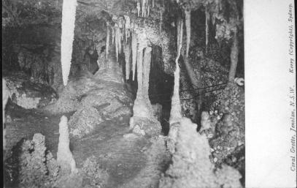 | 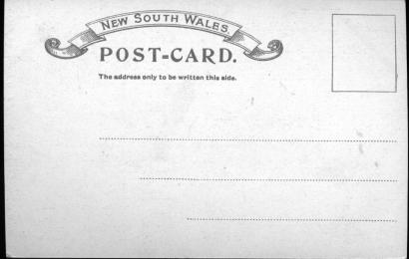  The back of series 3A

This series includes some interesting demonstrations of Kerry’s enthusiasm for being 'up with the times' which characterised many aspects of his business. Although many
of the cards depict views taken in previous years, 3.14 depicts the Minaret in River Cave, the discovery of which was first announced by Wiburd and Edwards on 6 June
1903, yet the postcard is recorded below as being postmarked only one year later (after photography, shipping the negative to Germany, printing, and shipping postcards back to Australia). Equally striking is the car that appears on 3.7. This is a Di Dion Bouton single-cylinder eight-horsepower, and it is certain that it was the first car driven to Jenolan - by Mr. Bert Beckman in June 1903. The journey from Blackheath took 9 hours. Kerry was on the spot to record such a momentous event. (Havard, 1936)

JK00A.1 Coral Grotto, Jenolan, N.S.W. H [Jenolan pm.13 Nov.1903]
JK00A.2 Aladdin Grotto, Jenolan, N.S.W. H [pm.1 Jul.1903]
[This cave is particularly difficult of access, and in fact was closed to the public because of this. We have one card where the sender has written 'Got Here!' We detect a note of joy.]
JK00A.3 Lucinda Cave, Jenolan, N.S.W. H [pm.5 Apr.1904]
JK00A.4 The Curios, Jenolan, N.S.W. H [ms.29 Nov.1903]
JK00A.5 Entrance to Gem of Jenolan, N.S.W. (s.n.a. JK00.4) H
JK00A.6 Jenolan, N.S.W. H (Actually a view of Caves House) [pm.24 Dec.1903]
JK00A.7 Gem of the West, Jenolan, N.S.W. V [pm.2 Jan.1904]
JK00A.9 Mafeking Cave, Jenolan, N.S.W. V [pm.6 Jan.1908]
JK00A.10 Devil's Coach House, Jenolan, N.S.W. V [pm.28 Feb.1904]
JK00A.11 Crystal Palace, Jenolan, N.S.W. V (s.n.a. JK0.1) [pm.29 Feb.1904]
JK00A.12 Katie's Bower, Jenolan, N.S.W. V [pm.12 Feb.1904]
JK00A.13 Grand Arch and Bridge, Jenolan, N.S.W. V [pm.5 Apr.1904]

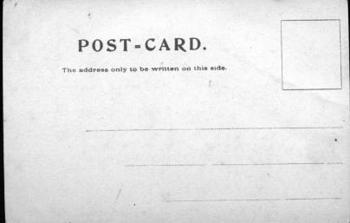 | This is the back of series 3B; series 3C and 3D appear more or less the same, but can be distinguished by measurements as indicated in the key.

JK00B.1 Coral Grotto, Jenolan, N.S.W. H [ms.6 Jun.1904]
JK00B.2 Aladdin Grotto, Jenolan, N.S.W. H [pm.17 Jun.1904]
One card is inscribed by the sender 'This is one of the most beautiful caves in the world.'
Another has a very formal statement, 'The Jenolan Caves were made known to the public in 1841 and in 1887 electric light was installed in the principal ones. The entrances are protected by iron doors & the delicate formations by wire netting. No person is allowed to enter any of which unless accompanied by an authorised guide. It is difficult to describe these caves they are so beautiful.'
JK00B.3 Lucinda Cave, Jenolan, N.S.W. H [pm.3 Jun.1904]
JK00B.4 The Curios, Jenolan, N.S.W. H [ms.7 Jun.1904]
JK00B.5 Entrance to Gem of Jenolan, N.S.W. H (s.n.a. JK00.4) [pm.8 Jan.1904]
Message on one example says 'We were through here this afternoon. A little onwards are caves after caves of teeming masses of these clusters - the Alabaster Hall, Pincushion, Staghorns are some of the sights.'
JK00B.6 Jenolan, N.S.W. H [ms.6 Jun.1904]
JK00B.7 Grand Arch, Jenolan, N.S.W. H [pm.14 Nov.1904]
[View shows J.C. Wiburd with Jack Edwards, cave guide and exploring companion to Wiburd, standing at roadside, and visitors in car]
JK00B.8 Gem of the West, Jenolan, N.S.W. V [pm.6 Jun.1904]
JK00B.11 Crystal Palace, Jenolan, N.S.W. V (s.n.a. JK0.1) [ms.6 Jun.1904]
Sender says 'Would like this shawl, A beautiful thing'
JK00B.12 Katie's Bower, Jenolan, N.S.W. V [ms.7 Jun.1904]
JK00B.14 The Minaret, River Cave, Jenolan, N.S.W. V [ms.6 Jun.1904]
JK00B.15 Carlotta Arch, Jenolan, N.S.W. V [pm.2 Jun.1904]
[view looking up through the arch from below]

JK00C.1 Coral Grotto, Jenolan, N.S.W. H [pm. 9 Sep.1905]
JK00C.2 Aladdin Grotto, Jenolan, N.S.W. H [pm.25 Jun.1905]
JK00C.3 Lucinda Cave, Jenolan, N.S.W. V [pm.1 Oct.1907]
JK00C.4 The Curios, Jenolan, N.S.W. H [pm.29 Dec.1905]
JK00C.5 Entrance to Gem of Jenolan, N.S.W. H (s.n.a. JK00.4)
[ms.Easter 1905]
JK00C.6 Jenolan, N.S.W. H [pm.4 Jun.1905]
JK00C.7 Grand Arch, Jenolan, N.S.W. H [pm.23 Oct.1905]
JK00C.8 Gem of the West, Jenolan, N.S.W. V [pm.29 Apr.1905]
JK00C.11 Crystal Palace, Jenolan, N.S.W. V (s.n.a. JK0.1) [pm.22 Mar.1905] JK00C.12 Katie's Bower, Jenolan, N.S.W. V [pm.16 Aug.1904]
JK00C.14 The Minaret, River Cave, Jenolan, N.S..W. V [pm.12 Apr.1905]
JK00C.15 Carlotta Arch, Jenolan, N.S.W. V [pm.2 Apr.1905]

JK00D.1 Coral Grotto, Jenolan, N.S.W. H [pm.26 May 1905]
JK00D.2 Aladdin Grotto, Jenolan, N.S.W. H [pm.17 May 1905]
Again, this card has attracted special notice from a sender [Jenolan pm. 2 Nov. 1905]:
'This is I think the loveliest thing in the whole of the caves. It is a most difficult cave to go through. We were through on last Friday and when we came out I don't think our best friend would have recognised us. We were simply covered in mud. Pleasant, eh. I did not mind, it was so beautiful. The guide lights up the whole thing and then it almost takes your breath away. Every colour and different shades from white to deep pink and red which of course you have to imagine in this view. Yes, Kerry's have a large place in Sydney.'
It is perhaps interesting that although this card has an undivided back, the sender of one copy has written on the address side as if it was divided, and has placed the stamp on the picture side. [pm.5 Jul.1906]
Another has drawn his own dividing line [pm. 20 Jul 1906]
JK00D.3 Lucinda Cave, Jenolan, N.S.W. H [pm.25 Sep.1906]
JK00D.4 The Curios, Jenolan, N.S.W. H [pm.19 May.1905]
JK00D.5 Entrance to Gem of Jenolan, N.S.W. H (s.n.a. JK00.4)
[pm.9 May.1905]
JK00D.6 Jenolan, N.S.W. H [pm.5 Jun.1905]
JK00D.7 Grand Arch, Jenolan, N.S.W. H [pm.11 Jun.1905]
JK00D.8 Gem of the West, Jenolan, N.S W. V [pm.31 May.1905]
JK00D.11 Crystal Palace, Jenolan, N S W. V (s.n.a. JK00.1) [pm.7 May 1906]
JK00D.12 Katie's Bower, Jenolan, N.S.W. V [pm.20 Dec.1905]
JK00D.14 The Minaret, River Cave, Jenolan, N.S W. V [pm.27 Mar.1905]
JK00D.15 Carlotta Arch, Jenolan, N.S.W. V [pm.2 May 1905]

JK00E.9 (Mafeking Cave) V
[This may simply be an accident of printing - we do not know]

JK00F.6 Jenolan, N.S.W. H
[View is largely in greenish tonings but all roofs are bright red. The quality of colour is such that it appears to have been printed as such, but may have been hand-coloured with unusual precision by a retailer or hobbyist. The only example we have seen was purchased by Dr. Bill Halliday in the U.S.
So, it may be that coloured cards were produced specifically for sale in U.S.A.]

*** Currently in Journey to Jenolan exhibit

SUMMARY : Jenolan 00 - Cards known to date.

 |  | A | B | C | D | E | F
00.1  00.2  00.3  00.4  00.5  00.6  00.7  00.8  00.9  00.10  00.11  00.12  00.13  00.14  00.15 | Coral Grotto  Aladdin Grotto  Lucinda Cave  The Curios  Entrance to Gem of Jenolan  (Caves House view)  Grand Arch (with car)  Gem of the West  Mafeking Cave  Devil's Coach House  Crystal Palace  Katie's Bower  Grand Arch & Bridge  The Minaret  Carlotta Arch | *  *  *  *  *  *  *  *  *  *  *  * | *  *  *  *  *  *  *  *  *  *  *  *  * | *  *  *  *  *  *  *  *  *  *  *  *  * | *  *  *  *  *  *  *  *  *  *  *  *  * | * | *

